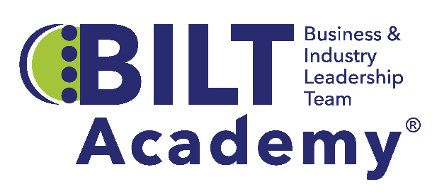 |  |   

The Business & Industry Leadership Team (BILT) Academy®
Cohort 6 Application and Academy Requirements

The BILT Academy is designed to assist community and technical colleges in their efforts to actively engage local business and industry in co-leading college programs through implementation of the Business & Industry Leadership Team (BILT) model. Interested colleges are invited to apply to become part of Cohort 6. Details of the application process and Academy participation follow. Applicants may email BILT@cord.org with questions about the application process or BILT Academy program.

Application Due Date and Milestones:
Application Due: April 14, 2025
Applicants Notified: April 25, 2025
Academy Duration: May 2025 – April 2026
A pre-recorded webinar with information for potential applicants is accessible here.

Background:
Led by the Center for Occupational Research and Development (CORD) and BILT subject matter experts, the BILT Academy provides technical assistance services at no cost to participating colleges. The Academy is a training program of the Pathways To Innovation Through Strategic Employer Engagement (PTI) project, designed to develop strong business engagement between technical education programs and the employers who seek to hire graduates of these programs. The project builds on the National Science Foundation-supported Business and Industry Leadership Team (BILT) model, a proven method for strategic employer engagement developed by Principal Investigator Dr. Ann Beheler. Colleges engaged in the BILT Academy learn how to develop employer relationships that yield workforce intelligence at a depth and with a frequency to facilitate continuous program improvement and innovation. Through the Academy, colleges receive coaching and professional development to support creating a BILT for a single technical discipline.

What’s So Unique About the BILT?
The BILT model puts businesses in a co-leadership role for community college technical programs. The frequency, specificity, and depth of business input, coupled with an industry-led governance structure, sets the BILT model apart from traditional advisory committees. BILTs embrace the notion that employer engagement is not an event, but a process built on trusted relationships between colleges and companies. BILTs leverage the sector knowledge of employers and teaching expertise of faculty to foster powerful collaborations that ensure program curriculum meets the needs of business and that students graduate workforce ready. Learn more about the BILT model.
Purpose/Format: The BILT Academy provides professional development and technical
assistance through one-on-one coaching and cohort events designed to assist two-year colleges in their efforts to build strong and sustainable employer relationships.
Eligibility: Teams must represent technical programs that are eligible for funding support from the NSF-ATE program.
Cost: No cost for participating colleges

College Commitments:
- Identify in-demand occupation/technical discipline on which to focus. This should be a program, such as cybersecurity or mechatronics, not a department like Information Systems. Note: this application is for assistance with a single program, not multiple programs.
- Identify a faculty member and an administrator from the college as key points of contact for the team. Commit appropriate time and personnel to administrative and logistical tasks essential for recruiting and establishing an effective BILT.
  - Team leads will submit periodic progress updates using a short Google form.
  - Team leads will receive training on the construction of pro forma KSAs, create the KSAs for their program in consultation with their coach, submit a final KSA list two weeks prior to the KSA analysis meeting, and recruit a minimum of 8-10 subject matter experts for participation in the KSA meeting.
- Identify an employer who understands the benefits of employers “co-leading” college programs and who commits to actively participate monthly as part of the BILT Academy team
- Develop an active BILT for the technical discipline identified, including committing to an implementation schedule that follows the BILT Annual Cycle of engagement activities.
- Expand and diversify employer partnerships by adopting the BILT model.
- Participate in Cohort 6’s monthly meetings supporting each step of the BILT annual cycle.
- Participate in monthly team calls with a dedicated BILT coach and continuously update an action plan for local BILT implementation.
- Identify two team members who will attend the HI-TEC Conference (July 21-24, 2025) for in-depth BILT professional development and cohort activities. (Travel funding provided)
- Document lessons learned during Academy experiences.
- Implement BILT model as prescribed in cohort training, coaching sessions, and resource tools.
- Create a plan for sustaining and expanding the BILT after the coaching period has ended.

College teams participating in the BILT Academy benefit from:
- Technical assistance from an experienced BILT coach
- Cohort meetings focused on implementation support and professional development
- Tools, templates, and resources for BILT implementation
- Facilitation support for one KSA analysis meeting. The KSA analysis enables colleges to prioritize the knowledge, skills, and abilities (KSAs) employers expect workforce-ready graduates to possess 12-36 months into the future.
- Intensive training workshop and participation in HI-TEC conference, July 21-24, 2025.

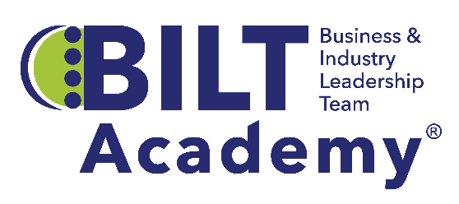
Cohort 6 Application
This application should accurately reflect your college’s relevant experiences, planning activities, and desired benefits of participation. All items below must be completed, including the identification of all three team members. Email your application as a Word file on or before April 14, 2025, to BILT@cord.org

Respond to each item in the spaces provided below; rows will expand as you type.
Feel free to provide as much information as you deem appropriate.

Section I: Your Institution and Participating Program

Name of College:
College Website:
Program* that will adopt the BILT Model:

Team Members:
Lead Faculty Contact Name:
Title:
Address:
City: State: Zip:
Email: Phone:
Lead Administrator Contact Name:
Title: (Associate Dean or above)
Address:
City: State: Zip:
Email: Phone:
Lead Employer** Contact Name:
Title: Company:
Address:
City: State: Zip:
Email: Phone:

*The discipline must be eligible for NSF-ATE program support
**This individual will be expected to participate in monthly BILT Academy activities.

Current Advisory Committee Members:
If your institution currently has a business advisory committee for the program area that will be the focus of your BILT, please list its current members. If your program is new, please list potential members. Add rows below as needed.
Name | Company | Title | Describe Level of Current Engagement

Section II: Your Experience
Experience with Employer Engagement
Describe your related employer engagement efforts (i.e. identifying workforce needs, activities with your existing business advisory committee including soliciting feedback on curriculum and industry credentials, developing work-based learning opportunities, apprenticeships, etc.) Please also describe the frequency of meetings, the number of employers attending, and job titles (or functions) of those who actively participate.

Section III. Your Partnerships
Describe below the partnerships your college will leverage and/or develop to support BILT implementation. Identify the entities involved (departments, educational institutions, employers, industry associations, workforce development agencies, community organizations) and describe how the partnerships will help facilitate BILT implementation, provide work-based learning opportunities, and support recruitment. Specify if a partnership already exists or is planned.
Internal Partnerships:

External Partnerships:

Section IV. Motivation and Desired Benefits
What motivated your program/college to pursue adoption of the BILT model?

How could your college team benefit from participation in the BILT Academy?

Institutional Commitment

[Name of College] affirms the proposed BILT Academy Team is committed to active participation in, and completion of all Academy requirements specified in this application.

Name and Title of College Dean or Vice President

Signature of Named Individual Date

